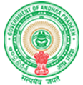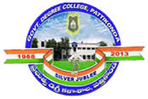**Government Degree College**

**ACCREDITED BY NAAC WITH ‘B’ GRADE** **Pattikonda,Kurnool (Dt),A.P.518380.**

**Dr.M.Purshotham Reddy,**

**Principal,**

**Provide the details of the performance of the institution**

**In our college most of the female students are from rural background. Our  
College is very much committed to work as per its Vision and Mission. Majority  
of the villagers, farmers, parents still follow the older tradition. To  
empower the women folk at a larger scale and uplift every village to the main  
stream, staff of the college put maximum efforts to convince, motivate and  
promote for higher education of female wards. Keeping the thought in mind that  
one educated female can lead the rest of the family towards quality education,  
every neighboring villagers, farmers, illiterate parents are made very much  
aware about the scope of higher education, provisions from State and Central  
government.**